Nursery Prospectus
Morgans Primary and Nursery School
Morgans Road, Hertford, SG13 8DR
01992 582162
www.morgans.herts.sch.uk
Email: admin@morgans.herts.sch.uk
Headteacher: Mrs Alis Rocca
Collaboration Commitment Communication Confidence Craftsmanship Creativity Curiosity

Contents Page Number
Head’s Welcome 4
Our Ethos and Values 5
The School Office/Governors/Equality &Diversity 6
Nursery Induction Programme/The Nursery Day 7
Our School – Morgans 7 Learning Powers 8
Learning in Nursery/Home School Communications 9 - 11
Uniform 12
Roleplay Picture of children 13
Pupil Premium/Keeping pupils safe Child Protection/Safeguarding/
Teaching and Learning 14
Special Educational Needs and Inclusion 15 - 17
School Information 18 - 22
Arrangements for Admissions 23 - 24

Head’s Welcome
Thank you for the interest you have shown in Morgans Primary and Nursery School. I hope that you enjoy reading our prospectus and it helps you to find out about life at Morgans.
Morgans is a two-form entry Primary and Nursery School, with the exception of our current Year 5 which is a three-form entry. Each year group has two classes, three in Year 5, led by teachers and supported by team of Learning Assistants. The Nursery is led by a teacher and is supported by a team of Early Years Practitioners.
Morgans School is a Community School administered by Hertfordshire County Council. The school has two buildings, Queens and Mandeville. The school offices are situated at the front of Queens building which can be accessed from Morgans Road. The school can also be accessed from an entrance in Wilton Crescent.

Morgans is a ‘Good School’ with outstanding features judged by Ofsted 2018. All of the adults around the school promote a clear vision and a positive ethos and community spirit. Our core purpose is to develop pupils into effective learners who love to learn and are committed to their learning and to provide every child with an outstanding education, so that they can develop into confident and resilient young people with a sense of self-worth – who believe they can make a difference in the world.

Our staff is driven by a strong moral purpose. We care about the wellbeing of our pupils and they work collaboratively to develop our pedagogy together. We foster a strong community and have great pride in our pupils and their achievements. Above all, we aim to ensure that every pupil is inspired to learn and achieves the best they can as a result of outstanding learning and teaching.

Our pupils are diverse, exciting and talented – and the same is true of our staff. We put huge emphasis on professional development, most of it in-house, and are proud of the high number of good and outstanding teachers who work in our school. Morgans is noted for our ‘can do’ attitude.

At Morgans we have a clear and focused vision which drives our thinking, learning and actions. Our vision is about Building Learning Power and is built around the work of Guy Claxton. We teach a development of values, habits and attributes to our pupils for them to be excited by learning, more effective at learning and develop as lifelong learners. We aim to ensure our pupils are prepared for their next stage in their educational journey. By the time our pupils reach Year 6 they will possess these attributes and be successful, effective learners ready to move on the next phase of their education.

Our large staff team are friendly and together with our Governors are all dedicated and committed to the continuing success of our school. We believe in creating a learning environment which motivates and stimulates our pupils. As such we encourage our pupils to care for themselves, care for each other and care for their community. We believe that it is important for our pupils to develop a love of learning through an exciting curriculum and a clear understanding of how they can learn successfully.

We are keen to involve our pupils and parents in all aspects of school life. We are always pleased to show prospective pupils and parents around our school. For many parents one of the hardest decisions they need to make is where to send their child to school. Although all schools teach the Early Years Foundation and National Curriculum, every school has an individual style and ethos and it is important that your ideas of how your child should be educated match the style of the school to which you send your child. We would always strongly recommend to any prospective parent that they arrange to visit our school during a working day to see if they believe their child will be happy here.

Alis Rocca
Head teacher

Our Ethos and Values

We believe in an inclusive education where all pupils are nurtured, valued and encouraged to love learning. We believe all pupils should feel safe and secure to grow into confident, independent learners who are not afraid to make a mistake or take a risk. We know that pupils learn best when they are excited by and engaged in their learning. We teach our pupils the skills they need through an inspiring, creative curriculum that dares to be different.

We can do this because we provide a committed staff team who offer high quality teaching and inspiring learning environments drawing on a wealth of knowledge, strengths and skills. We value achievement and strive to ensure each child is appropriately challenged and reaches their full potential. We empower our pupils to become responsible citizens in our diverse community. We know that working together as a team - staff, parents, governors, the local and wider community, enables us to meet the needs of all of our pupils.
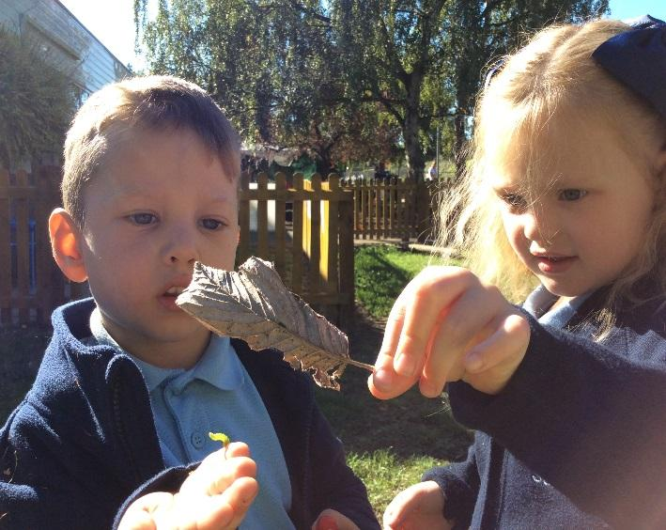

Children showing curiosity as they explore and learn new things.

General Information

The School Office

The School Office is open from 8.30 am to 4.30pm Monday to Friday. Please note that during busy times at the beginning and end of the school day, the Office can be contacted by email admin@morgans.herts.sch.uk. In the front Reception Office there is a secure post-box located in the lobby. There are also drop boxes for receipt of forms and other returns just outside the reception window.

Governors

As a community school we have our own Governing Body. This consists of volunteers nominated by the parents, school staff, plus governors co-opted for the skills they bring. Our governors’ names are listed on the school website. Our Chair of Governors is Mr Guy Chiswick. They are happy to discuss all aspects of the school. They have a legal responsibility to work as a body to manage the school, are actively involved in school life and attend training courses throughout their terms of office. If you wish to contact one of our school governors please do so via the School Office or via email on governors@morgans.herts.sch.uk

Equality & Diversity

The concept of equal opportunities is a priority in our school. All pupils and parents regardless of race, religion, ethnicity, disability and gender are welcome and will be encouraged to participate fully in the life of the school. We work to ensure that all individuals are valued and have the opportunity to develop their full potential within the context of mutual respect and fairness.

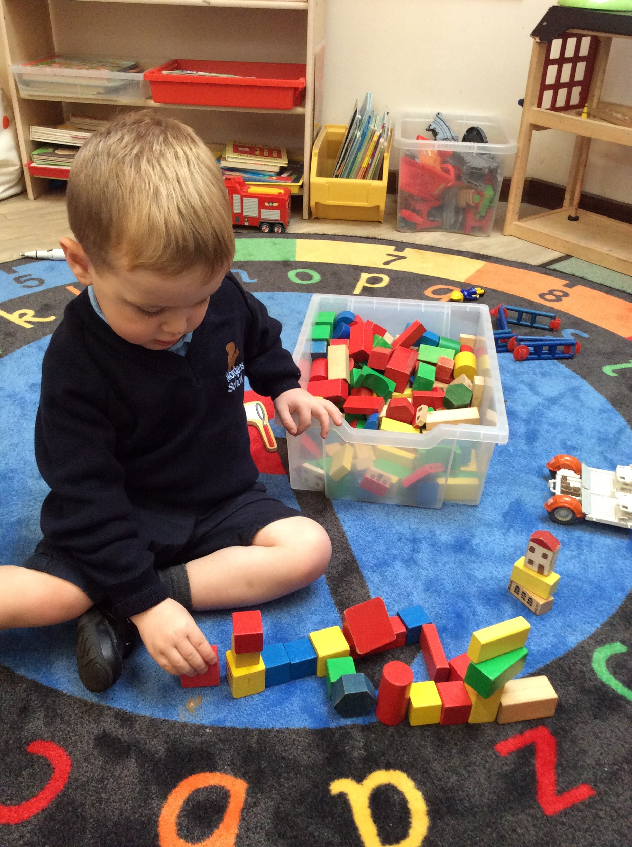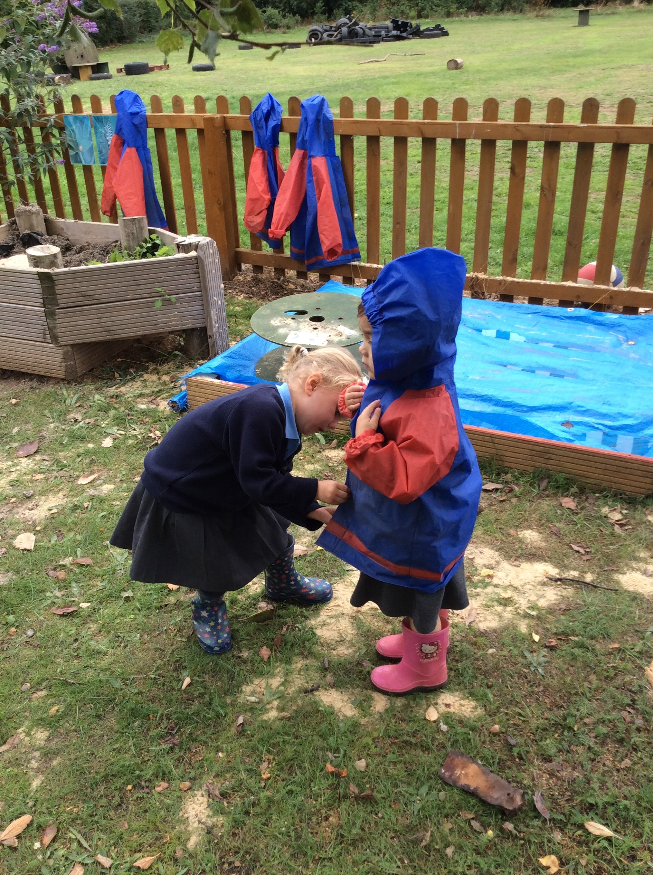

Children showing Craftsmanship and Commitment

Nursery Induction Programme

The school has a very structured induction programme to help the pupils settle in happily. The programme has been designed to provide a gentle start for our young pupils. A member of the Nursery team will make a visit to you at home prior to the pupils starting school to allow your child to start building a positive relationship with their teachers and for the teacher to get to know them in a place where they feel most comfortable. Pupils and parents then have transition visits in the nursery before starting Nursery full time. Parents are invited to attend an information meeting with the Head teacher and the Nursery Teacher to learn a little more about the school.

The Nursery Day

We offer a variety of options for your child to attend Nursery and try to be as flexible as possible to suit the needs of your family. All pupils are entitled to 15 hours free Nursery education. In addition, some parents are also eligible for 30 hours free childcare and this funding can also be used. If your child has a part time place, you can also opt to purchase extra sessions, depending on availability, at a chargeable fee.

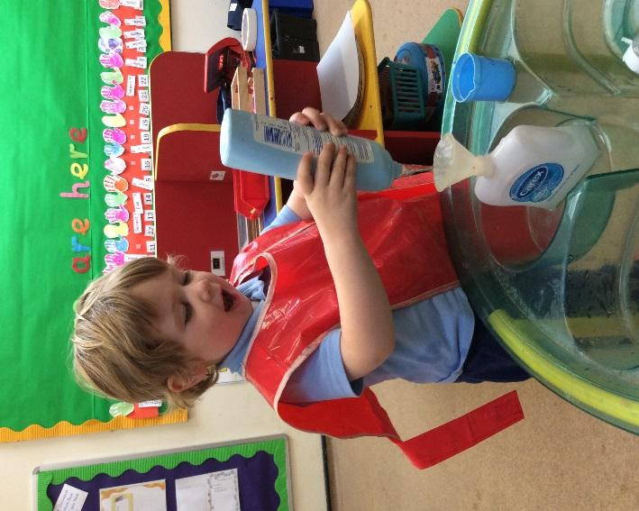
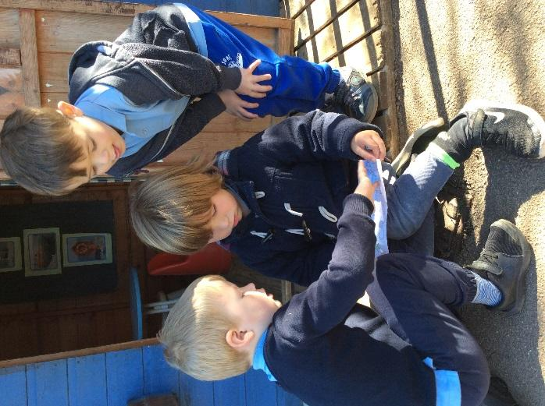

Children communicating their ideas Showing high levels of fascination

Morgans 7 Learning Powers

Collaboration Commitment Communication Confidence Craftsmanship Creativity Curiosity

To support the development of the pupil’s learning skills, we have our Learning Power Bears. This is based on the work of Professor Guy Claxton. We use the Learning Power Bears to talk with the pupils about how they can grow into better learners.

Learning in Nursery

Research tells us that pupils can only learn when they are relaxed and happy. Therefore, in Early Years we use a play based approach in all our learning. At Morgans we believe that the best learning happens when the pupils are engaged in activities of their own choosing, as well as learning about a range of themes and topics such as the seasons and a variety of festivals and celebrations. This means that we follow the pupil’s interests and adapt our planning so that we can teach skills through a learning context which excites and inspires the pupils to learn more. Our approach is in keeping with the government’s recommendations on Early Years education, as detailed below.

The Principles of Learning in Early Years Foundation Stage
- A Unique Child
Every child is a unique child who is constantly learning and can be resilient, capable, confident and self-assured.

- Building Positive Relationships
Children learn to be strong and independent through positive relationships.

- Creating Enabling Environments
Children learn and develop well in enabling environments, in which their experiences respond to their individual needs and there is a strong partnership between practitioners and parents and carers.

- Learning and Development
Children develop and learn in different ways. The curriculum supports the development of all children.

The Characteristics of Effective Learning

Engagement - Playing and exploring
- Finding out and exploring
- Playing with what they know
- Being willing to ‘have a go’

Motivation - To learn actively
- Being involved and concentrating
- Enjoying achieving what they set out to do
- Keeping trying

Thinking - To be creative and to be able to think critically
- Having their own ideas
- Making links
- Choosing ways to do things/Solving Problems

Early Years Curriculum
The Foundation Stage Curriculum for Nursery and Reception covers three Prime areas of learning. These areas are fundamental, work together, and move through to support development in all other areas. Personal, Social & Emotional Development, Communication & Language and Physical Development. Four specific areas that are taught include the essential skills and knowledge for our pupils. These are Literacy, Mathematics, Understanding the World and Expressive Arts and Design.

Learning Environments
The way the environment is set up and the resources available to the pupils is a key component of effective Early Years provision. We think carefully about the skills which the pupils can develop in each area of the indoor and outdoor environment and ensure that the resources we provide allow the pupils to make progress. We are very lucky to have a fantastic outdoor environment at Morgans which the pupils take full advantage of. We use the outdoor space in all weathers because pupils need to be active in their learning.

Nursery
The Nursery Day wherever possible follows a consistent routine, allowing children to feel safe and secure in their new learning environment. We use a ‘Visual timetable’ so that children can see what happens next in their day.

Whilst at Nursery, the children experience ‘Explore and Learn’ time in an Enabling environment, with skilled practitioners supporting them to learn and to take them on in their learning, either through the use of guiding questions or providing a particular resource or setting up a particular learning opportunity which will support your child’s development.

To develop your child’s active listening skills and their ability to listen as part of a larger group, they also experience carpet learning time. This may comprise of sharing a story, singing action and number rhymes; interacting with the Smartboard or introducing them to a learning opportunity which they may then choose to engage with during our ‘Explore and Learn’ sessions.

Adult-led activities are also planned so that your child learns to join in with an activity that they have not necessarily chosen themselves and which allows them to work on an area for development such as mark-making; cutting skills; turn-taking or number work. This situation also teaches them to respond to the needs and wishes of other children in the group as they share the teacher’s time and learning resources.

The children have the opportunity during ‘Explore and Learn’ time to work either inside in the Nursery classroom or outside in all weathers, allowing children to develop key physical skills and to explore their knowledge and understanding of the world as they look for minibeasts; plant and grow a variety of plants and notice changes in our world as we move through the seasons. They are also able to join in with P.E lessons in the hall where they may learn to move in different ways; follow a physical circuit and learn to share space and avoid obstacles as part of a larger group, and to make use of the extensive school grounds.

During their time at nursery, we want your child to be empowered to carry out things for themselves wherever possible. This includes developing self-care skills such as using the toilet independently, getting ready for outdoor play by putting on their coats and welly boots and helping to put away the toys at the end of the session.

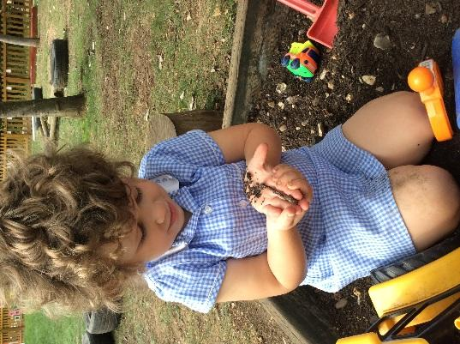
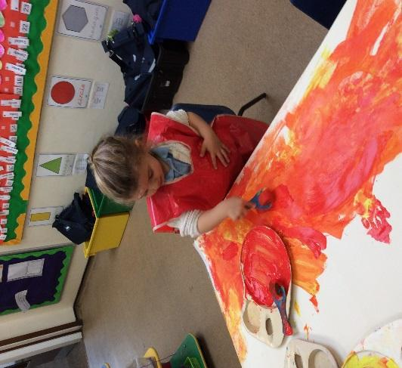

Creativity and Curiosity at their best

Home School Communications

We use an online system to communicate with parents. Once your child has joined Morgans we will send you a registration letter which will give you instructions of how to set up an account.

Morgans Mail is a fortnightly newsletter that is sent to parents via our electronic communications system telling them about the various learning activities in school. The school website is regularly updated and contains useful information on the school.

The Head teacher is always available to talk to parents. In addition, we also have the more formal opportunities for parents to hear how their pupils are progressing. In the autumn and spring terms, we have Parent Consultation when parents can come and look at their child’s work and discuss their child’s progress with the teachers. In the summer term, parents receive a written report that explains the progress the
pupils have made in all areas of learning. At the end of the academic year parents are invited to a moving on progress meeting.

Uniform
We would encourage Nursery children to wear a simplified form of Morgans uniform and suggest that a sky blue polo shirt and plain navy v-necked jumper or cardigan, with a free choice of trousers/skirt/shorts and shoes. Parents will receive more information about suitable clothing in their Welcome Pack. Uniform is worn by all pupils from Reception upwards. Full information about the school uniform is available in the Welcome Pack.

Kids Connection in Hertford are the stockist for all items with the school logo on; however, there is the option to buy non-logo items from major chain stores – but please do buy the required colours and styles ie navy blue V-neck jumpers and cardigan, not round neck sweatshirts or any other variation in style or colour.

Pupils also need a book bag, and spare clothes and wellingtons - all are detailed in the Welcome Pack. All items of clothing and equipment must be clearly named. All pupils in school will also need warm outdoor clothing and footwear.

Kids Connection can be contacted at www.kidsconnection.co.uk
14 Market Place, Hertford SG14 1DQ Tel: 01992 587466
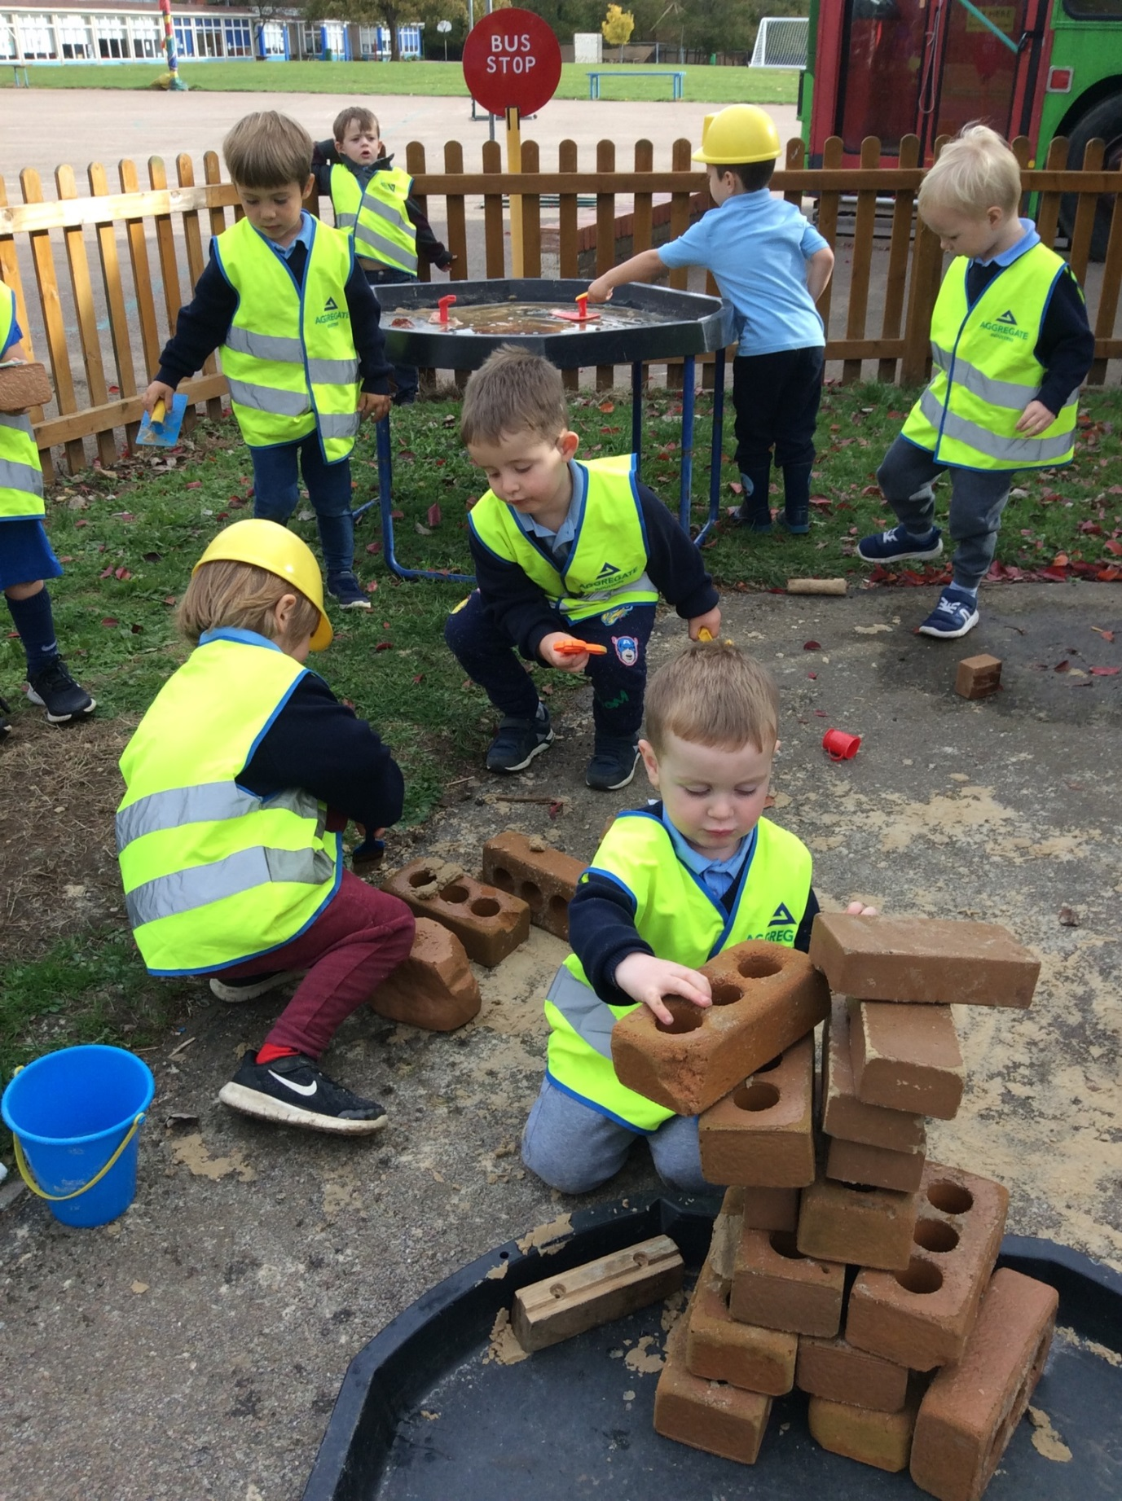

Role play on the building site with children collaborating as they play together.

Pupil Premium

Previously the school received additional money called Pupil Premium for all pupils who received free school meals. Now that all pupils automatically receive universal free school meals you should still register for free school meals in order for us to continue to benefit from Pupil Premium. We strongly advise that you to do this so that we can gain additional income for the school. For each child in Nursery who receives Pupil Premium we receive an additional sum of money to support their education in school.

Parents can apply
∙ online at: www.hertsdirect.org/freeschoolmeals www.lookinglocal.gov.uk/hertsdirect
∙ phone: 0300 123 4084 between 8:00am- 8:00pm Monday to Friday, or between 9:00am- 4:00pm Saturday

Alternatively, the School Office will be happy to apply on your behalf.

Keeping Pupils Safe Child Protection and Safeguarding

We have a detailed child protection policy which reflects our duty of care for our pupils and highlights the strategies we would use based on the latest DfE guidance. “Keeping Pupils Safe in Education (2016)” The purpose of the policy is to inform staff, parents, volunteers and governors about the school's responsibilities for safeguarding pupils and to enable everyone to have a clear understanding of how these responsibilities should be carried out.

Prevent Duty: As part of our safeguarding responsibility all staff are trained and are aware of their prevent duty under the Counter Terrorism and Security Act 2015 which aims to prevent people from being involved in terrorism or supporting terrorism.

Teaching and Learning

We believe all pupils at our school regardless of race, gender, or ethnicity should have the opportunity to learn through a rich curriculum that gives a wide range of experiences. Whilst in our school we want our pupils to be:

- Active and confident learners
- Able to think creatively
- Able to develop independence of thought - ask challenging questions
- Able to take risks in their learning
- Able to co-operate with each other and be part of a community
- Willing to ask for help
- Curious and motivated
- Able to sustain interest and concentration
- Challenged and excited to learn
- Able to learn through a structured programme of activities which are suited to their
learning style and ensure their skills progress
- Happy and have fun in their learning
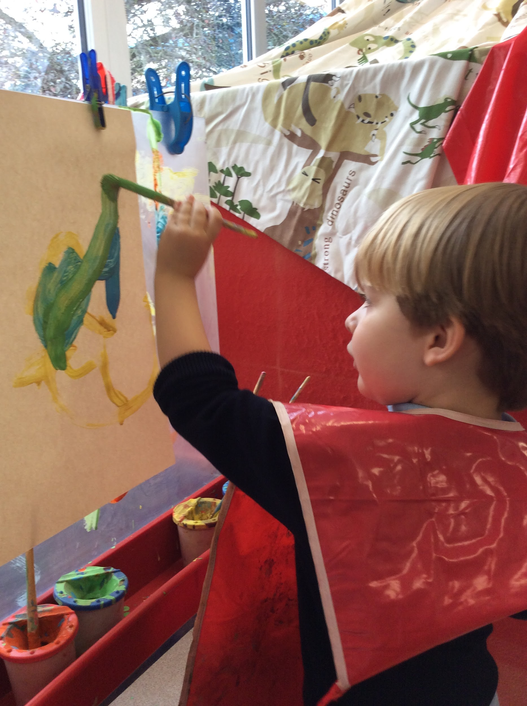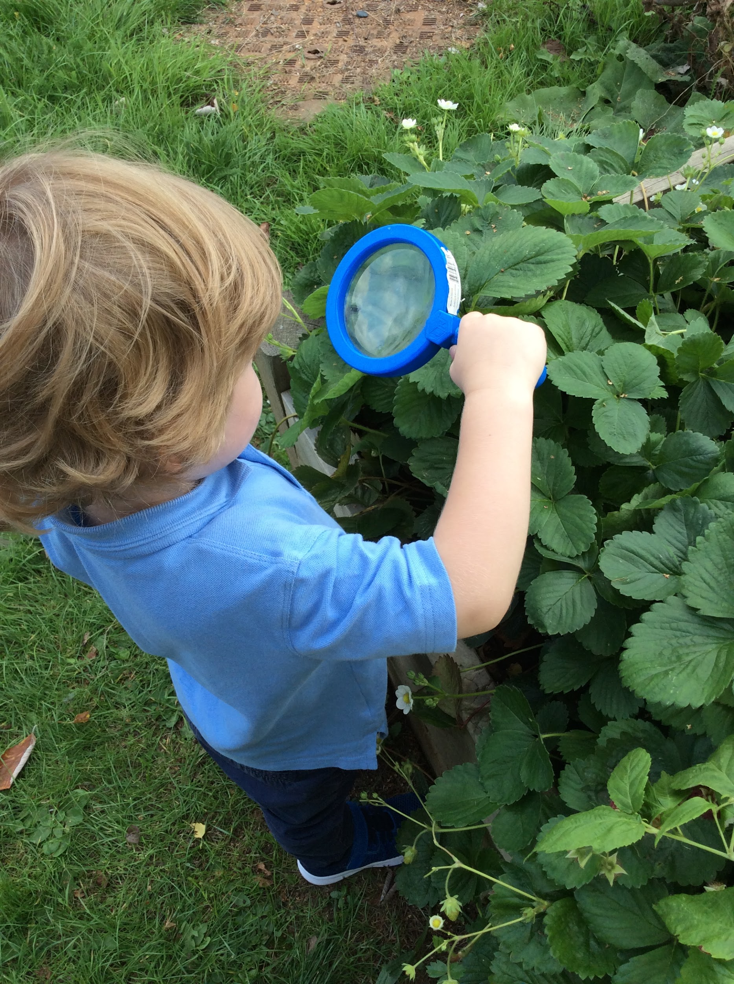
Craftsmanship, Commitment and Curiosity

Special Education Needs and Inclusion

How does the school know if pupils/young people need extra help and what should I do if I think my child may have special educational needs?
Parents have many opportunities to speak to staff if they are concerned about the progress their child is making. Class teachers are available for discussions at the end of every day and parents can also make appointment to see our SENCO by speaking to the school office. Prior to joining our school, our Nursery pupils receive a home visit from members of the Early Years team. This is a very good opportunity for parents to raise any concerns before their child even starts school.

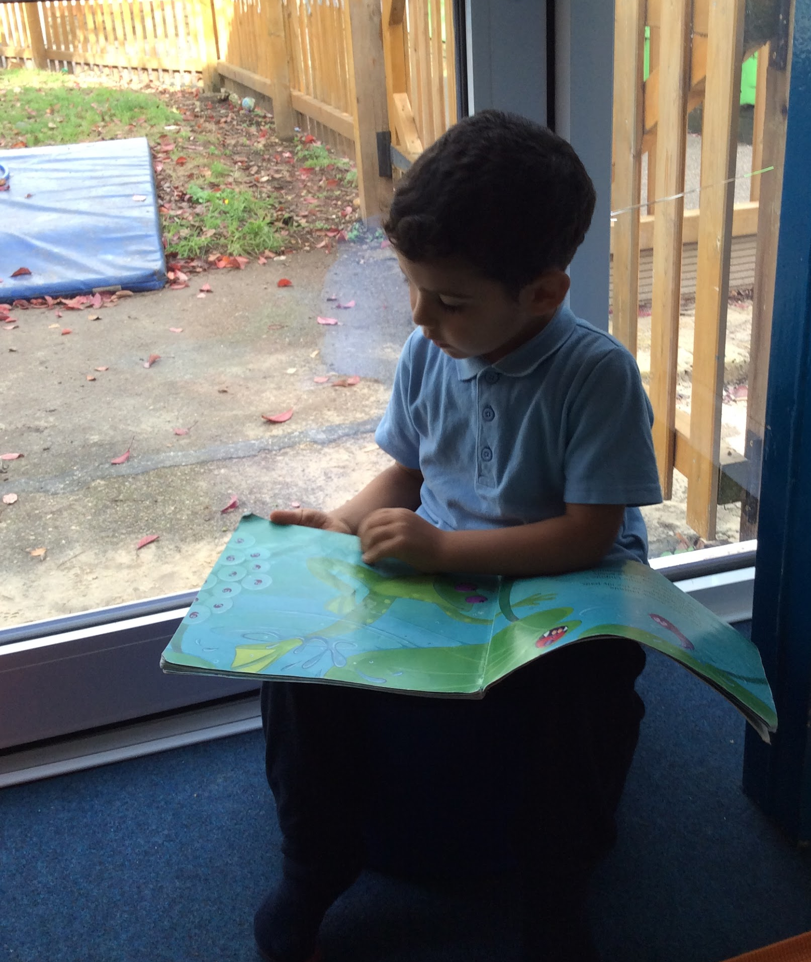
Creativity, Communication and Curiosity
How will school staff support my child?
The Nursery teacher and teaching assistants are responsible for the learning and progress of all pupils in the class. They are able to draw on support and advice from our SENCOs (Special Educational Needs Co-Ordinator) as well as external specialists such as the Speech and Language Therapist, Educational Psychologist and other advisory teachers.

Our SENCOs work closely with pupils, parents and teachers to identify additional needs and ensure appropriate provision is in place. The progress of pupils receiving special educational provision is also monitored by the governing body. The governors receive termly progress information from our SENCO and there is a governor specifically assigned to monitor Inclusion. We also have access to a play therapist who works with pupils with identified emotional needs with the agreement of their parents.

We can access advice and support from a number of professionals in school for example educational psychologists as well as signposting parents to the appropriate professionals outside of school for example paediatricians, CAMHS (Child and Adolescent Mental Health Service) and support from our local pupil’s centre or family support worker.

How will I know how my child is doing?
Formal opportunities are available for parents to talk to their child’s class teacher each term during Parent Consultations. A written report is sent home in July, and there are a number of occasions through the year when parents are invited into school to see their child’s work. There are also informal opportunities to talk to class teachers at the end of the school day. Parents of pupils receiving special educational provision are invited to meet with the school-based professionals working with their child every term, to review and plan provision and agree future targets and next steps.

What training have the staff, supporting pupils and young people with SEND, had or are having?
All teaching and learning staff in the school support pupils with special educational needs. We have a wide and varied CPD program for all staff to ensure our team are well trained and have expertise in many areas. As well as sending staff members on external training courses we regularly invite experts into our school to deliver training to all members of staff. Alongside this training best practice locally is shared through networks such as the Head Teachers’ Consortium, Deputy Head Teachers’ Network and local SENCo meetings.

How will I be involved in discussions about and planning for my child’s education?
We aim to work very closely with parents of pupils with SEND, Class teachers and Teaching Assistants are available for informal discussions at the end of the day and we will often use a home/school diary or good news book to keep parents informed on a day to day basis. We also have regular planning meetings for pupils receiving special educational provision. These involve the parents, our SENCO, class teachers, and any external professionals involved with the child as appropriate. At these meetings, we will look at the child’s progress towards their targets, celebrate any successes and discuss any problems or barriers to reaching their targets. We will also set new targets and discuss ideas of how to support the pupils to achieve them.

How will my child be included in activities outside the classroom including school trips?
All school trips are planned to include all pupils in the year group. If your child has a special educational need that may make their participation in a trip more challenging then we look at how to make the trip safe and accessible to them. We conduct individual risk assessments for these pupils and will work with the parents to discuss and remove any barriers to their participation. For example, we might allocate additional adults to support your child or invite you to join us as a parent helper on our trip. Ratios for school trips are always at or above the standards set by Hertfordshire County Council.

How accessible is the school environment?
We endeavour to make our school as accessible as possible for all pupils and parents. Our school building was built in 1950 and as such wasn’t built with full accessibility for wheelchairs however we have worked to make the building as accessible as possible. We have two disabled toilets and changing facilities.

Who can I contact for further information?
The school office is always open throughout the day, 8.30am-4.30pm, and office staff can direct enquiries to the most appropriate member of staff. Appointments can be made to see members of the Inclusion Team and they will always endeavour to be available to address urgent concerns immediately. The team are also contactable by telephone and School Office: admin@morgans.herts.sch.uk

How will the school prepare and support my child to join the school, transfer to a new school or the next stage of education and life?
Parents and carers considering choosing Morgans Primary and Nursery School for their child are encouraged to visit the school for a tour with one of the senior leadership team. If your child has special educational needs we would encourage you to make an appointment to meet with our SENCO prior to your child joining the school to discuss their needs and ensure the appropriate support can be put in place. We visit all pupils entering our nursery and pupils who are new to our Reception either at home or in their current nursery setting. This visit enables our staff team to get to know the pupils a little, find out about their likes, dislikes and any support needed.

All of the pupils are also invited into school for a series of visits prior to starting school so they are able to feel comfortable and confident with the environment and the staff team.

Additional visits, activities and support are also provided for individual pupils where necessary. When a SEND child leaves our school mid-year or to attend a different primary school we will liaise closely with their receiving school, inviting them to a SEN review or attending a handover meeting at their school.

How is the decision made about how much support my child will receive?
The extra support your child will receive will be carefully matched to their needs, In order to identify the support needed we will work closely with parents and use all of the information available about your child for example careful assessments, their progress so far, observations of the child and advice from external professionals. Reviewing the level of support your child receives will be a key part of the regular planning meetings. It is our aim to develop the independence of all pupils and no child will receive full-time support from the same adult.

Safeguarding
If you have an appointment or are helping in a class, after dropping your child, please make your way around the outside of the school to the main entrance and sign in. If you are walking from the Mandeville building to leave at the Queen’s entrance or to visit the school office, you will need to walk outside the building, not through the school please.
Bikes and Scooters
We have a shelter for bikes and scooters situated outside both school buildings. If you would like to make use of these facilities, please contact the school office for a permit. For safety reasons, no bikes or scooters should be ridden within the school grounds.
Parking
There is no parking for parents and visitors within the school grounds unless you have a disability and are a blue badge holder. The main gates to the school car park are locked from 8.40-9.00am and from 3.00-3.30pm. If you need to use our disabled parking bay, you will need to arrive before these times to gain access.

When parking, please bear in mind that we are situated in a residential area, and please be considerate to our neighbours. Along Morgans Road we encourage a “one-way” system, to try to ease congestion and request that you always approach the school by coming up Queens Road and bearing right into Morgans Road, so that the school is on your left. When leaving, please head along Morgans Road in the direction of County Hall.

Parking Pledge
Parking for any school is always an issue and our school is no exception. The Senior Leadership Team regularly monitors and reviews parking outside Morgans School.
As adults, we are role models to all children and should always behave in a courteous and respectful manner to fellow drivers, pedestrians, staff and visitors.
By following our voluntary Parking Pledge, you will be helping to ensure that drop off and collection times at Morgans are as safe as possible. We ask you to support us to show your commitment to safe parking. This will hopefully encourage others to do the same. The Senior Leadership Team, along with our School Council pupils will have the responsibility of monitoring the success of our pledge.

I/We agree to:
- Walk to school whenever possible, including parking further from the school and walking the last part of the journey.
- Keep to the one way system around Morgans Road at the beginning and end of the school day.
- Obey all road signs on our school site, including the no entry signs on the car park gate at drop off and pick up times.
- Never park, drop off or pick up across the yellow zig zag lines or areas for emergency access – this is illegal and dangerous.
- Not park on the pavement or grass verges both on and off our school site.
- Not block resident drives – help us to be collaborative with our neighbours and local residents.
- Not park in the staff car park unless picking up or dropping off at The Dell or collecting a sick child.
- Not to park in the designated disabled bays unless you hold a valid disability parking permit.

Healthy eating
Children in Nursery, Reception, Years 1 and 2 are provided with a piece of fruit or vegetable as their snack each day. Children in Year 3 and above may bring a healthy snack each day for break time. Please ensure all snacks and packed lunches are healthy and do not contain fizzy drinks, chocolate, crisps. As a nut-free school, please ensure no items contain nuts, including peanut butter, some cereal bars etc.

School Lunch
For Nursery children attending all day, they have their lunch at Morgans School. The sessions are fully supervised by staff at all times. Parents must provide a packed lunch. We ask for it to be sent in a named lunchbox. We encourage healthy eating, so please avoid crisps and include fruit in your child’s lunch. As there are an increasing number of pupils with nut or nut-related allergies we are a nut free school. Please do not send in any foods (e.g. cereal bars) which contain nuts or sesame seeds or oil (e.g. hummous). We also ask parents to remind their pupils not to share any of their food with other pupils.

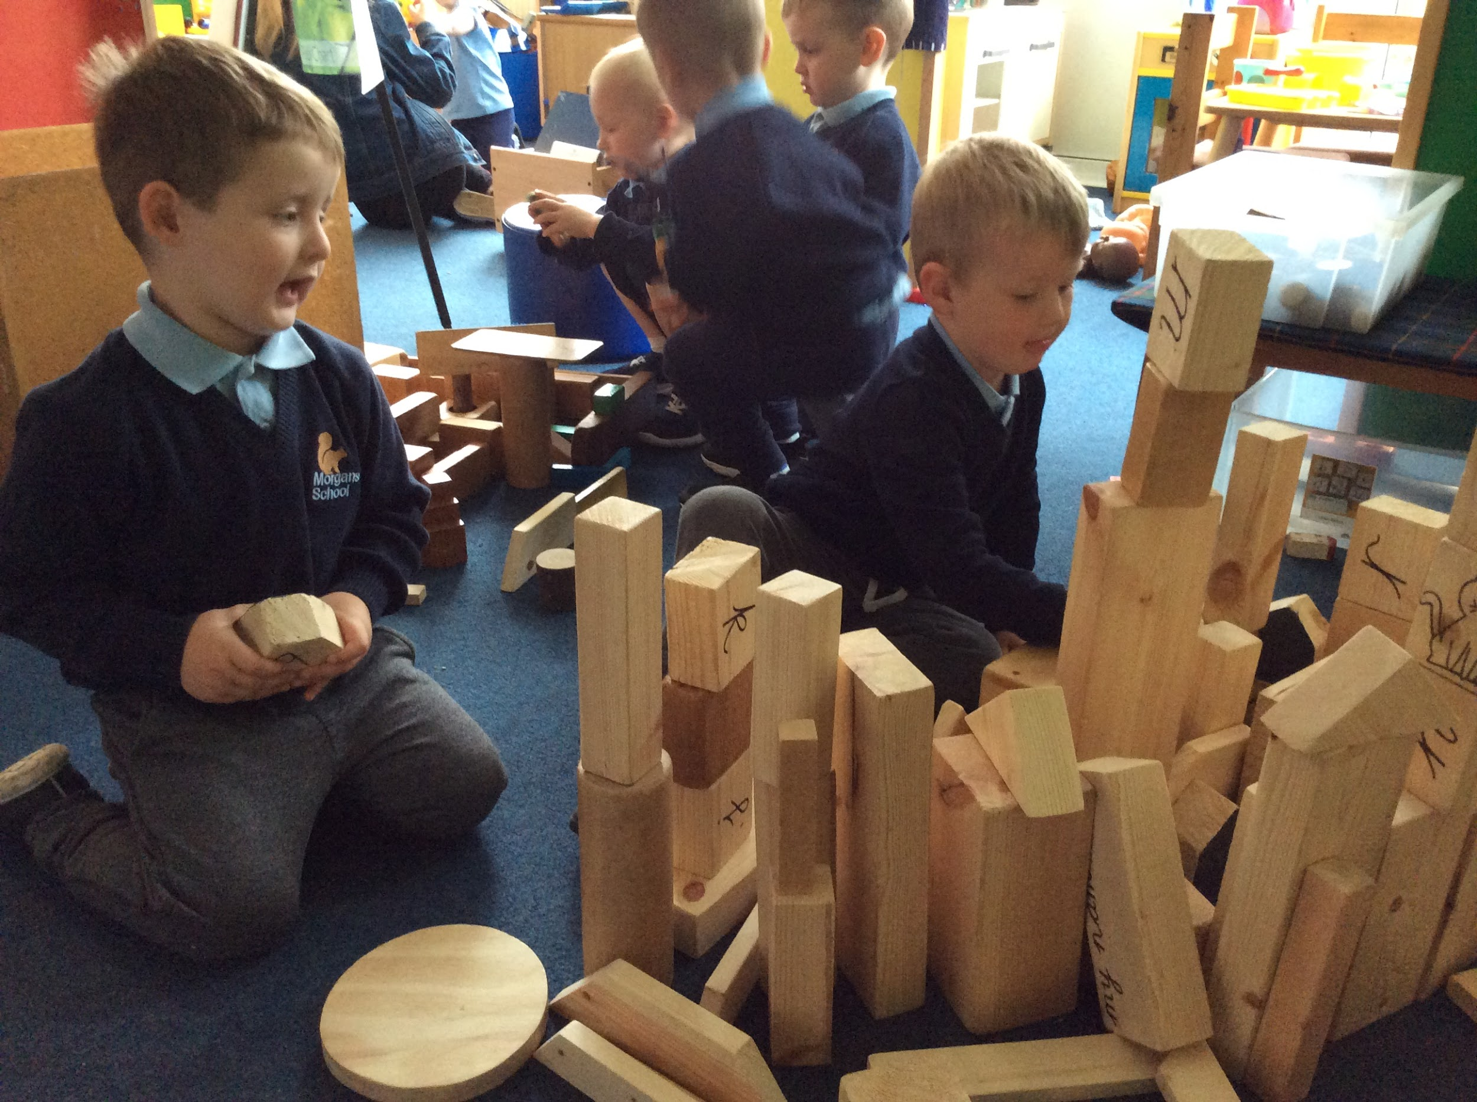

Craftsmanship, Commitment, Collaboration and Creativity

Friends of Morgans (FOMS)
There is a very active ‘Friends of Morgans’. All parents are automatically members. A committee is elected at each Annual General Meeting for the following school year. The committee coordinates with any parents who help with specific functions. It is through this active support that the school is able to purchase additional resources for the school. FOMS aims both to provide social links for the parents of pupils at the school and raise money. The money raised provides many things the school could not otherwise afford, but which benefit the pupils greatly. All parents are encouraged to become involved and help out at events, whether on a stall, making cakes, hanging bunting or many other jobs too numerous to mention. The Parents’ Association also organises the sale of second hand/used/nearly new school uniforms. FOMS has its own email address friendsofmorgans@gmail.com.

Absence
If a child is absent from school for any reason, we ask parents to telephone and inform the school by either ParentMail or by telephone (01992 582162) and leaving a message on the designated Attendance Line.

Requests for Absence
Although attendance is not compulsory in Nursery we do ask that if you are planning to take your child out of school you fill in the request for leave of absence form which is available from the office so that we know not to expect them in school.

Drop-off and collection
It is the parents’/carers’ responsibility to ensure that their child is dropped off and collected by a responsible person who should be over the age of 16, unless there is prior written agreement with the school. Nursery has a password system to ensure that only authorised individuals can collect pupils. You will be asked to provide a password at your home visit. The school will take responsibility for pupils as from 8.30am for morning sessions and 12.30pm for afternoon sessions. Before this time there will be nobody to supervise the pupils and therefore the welfare of the pupils is the parents’ responsibility.

Parent Partnership
We are pleased to share the education of your child with you. We endeavour to establish a positive partnership between parents, child and school in which information, successes and concerns are shared. As part of our annual routine we invite parents to formal Parent Consultation in the autumn and spring terms.

We also have meetings with pupils and parents to discuss their progress and their targets for the following half term. In the summer term a school report is written. The school report focuses on three key areas, your child’s personal, social and emotional development, their attitude to learning and the progress they have made with their learning during the year. Parents are welcome to meet with their class teacher to discuss this report. We hold open sessions each term when parents and other relatives may visit the school with their pupils.

Open Door Policy
Teachers are always available in their classrooms after school and are happy to discuss any concerns or answer any questions parents may have. If the school needs to know of a situation that has developed first thing in the morning, we do ask parents to come to the office so as not to disturb the pupils at the start of the day. The Head teacher is always happy to meet with parents and discuss any concerns or answer questions. Appointments can easily be made by contacting the school office. In addition, there are many occasions when we welcome parents to school, including: Christmas Nativity Plays, Curriculum evenings, Maths and Literacy Workshops, Open evenings and Sports afternoons.
As parent helpers/reading partners/lunchtime carers/class representatives these are all additional.

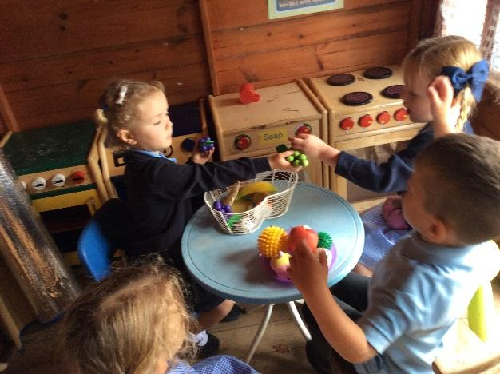

Collaboration, Communication and Creativity

Pupil Care Medicines
We take pupil’s welfare seriously and have a system of managing written agreements where pupils have to bring medicines into school. Pupils on a course of medicine are generally assumed to be not fit for school, but there are conditions like asthma or diabetes where we will help the pupils to manage their condition. Medicines can be brought to the school office clearly labelled. We have a consent form for all medicines, which is available at the school office. Parents of pupils with other conditions, or regular medication, should discuss the problem with the First Aid Lead before a course of action is decided upon. Pupils with asthma should have access to their inhalers at all times - we suggest they are kept in the teacher’s lockable cupboard. However, it is a parent’s responsibility to check the efficiency of inhalers, or indeed any other medicine held in school.

Personal Care
Sometimes pupils will still be wearing nappies or having accidents when they start coming to Nursery. If this is the case, we are happy to change them. Our policy is that nappy changing will be done by two members of staff. When a child has an accident we will help them to change into their clean clothes whilst encouraging them to become independent. We ask all parents to provide a change of clothes for their child in case of accidents.

Emergencies
Occasionally, accidents happen at school, or a child becomes unwell and it is necessary to contact a parent. It is very imperative that we have telephone numbers so that we can contact both parents as well as a further two contact numbers of friends or family who would be prepared to look after the child if the parents cannot be reached.

Charges and Remissions Policy
The governors have adopted the following policy on charging for school visits and activities.
- No charge will be made for activities and visits in school time, but a voluntary contribution is requested
- There is no obligation to contribute and no individual child will be penalised if parents decide not to contribute
- If insufficient contributions are received for a proposed activity it will not take place.

We hope parents will continue to support visits whenever possible, in order to enrich the pupil’s learning by providing first-hand experiences.

If parents are concerned about anything, it is important that they discuss this with their pupil’s class teacher to see if it can be resolved. If this does not help to resolve the issue, parents can discuss the matter further with the Head teacher or a member of the Senior Leadership Team. If parents are still not satisfied, the Governors of the school have arrangements for considering complaints formally. They have adopted the procedures recommended by Hertfordshire County Council and a copy of these can be obtained from the school office.

Extended Care - The Dell - Before and After School Club
We have a daily club, The Dell Out of School Club, run by an external organisation which enables pupils to be looked after from 7.30am to 6.00pm. Pupils are welcomed from the age of three. The Dell runs 50 weeks of the year and a charge is made. Please ask at the office for details. 30 hours funding can be used to pay for this provision.

Arrangements for Admissions
Admissions Policy
The admissions process for Nursery is separate from the rest of the school. Parents need to apply directly to school for a Nursery place. Please see the website for details. We have 60 places in Nursery.

Please see our Admission Policy for full details

30 hour funding (6 hours a day)
All 3 and 4 year olds are entitled to 570 hours of free early education a year, which is equal to 15 hours a week for 38 weeks of the year. Some 3 and 4 year olds may be entitled to an additional 570 hours of childcare per year, which is equal to 30 hours a week for 38 weeks of the year. The 30 hour free childcare entitlement is available to working families who meet the eligibility criteria. Parents can check eligibility at www.childcarechoices.gov.uk

Contact details for all registered providers in Hertfordshire can be found at www.hertfordshire.gov.uk/parents

Morgans Nursery offers pupils in receipt of 30 hour funding a place from 8.30am to 2.30pm.
Parents can collect their child at 2.30pm. Parents who would like extended hours can pay for their child to stay in the Nursery until 3.30pm at the cost of £5.10 per hour. This fee must be paid in advance to the school.

The 30 hour funding can be split between two providers as long as both agree to the split. Please contact the school if this is your preference.

The admission policy is available on our website – www.morgans.herts.sch.uk/admissions

15 hour place (3 hours a day)
Parents can apply for a 15 hour place from February. Session places will be offered by date of birth. When applying, parents can state their preference for morning (8.30-11.30am) or afternoon (12.30-3.30pm) sessions. The school will record this preference and offer the preference if spaces are available after the application deadline closes.

Morgans Playgroup currently offers extended lunch club hours for 15 hour pupils who only attend either morning or afternoon sessions. Arrangement for lunchtime supervision must be made directly with Morgans Playgroup.

Children who stay for both sessions will attend Morgans School lunchtime club. Parents must provide packed lunches. Parents wishing to collect their child at 3.30pm will be charged for lunchtime supervision, alternatively children can be collected at 2.30pm where no charge will apply. Lunchtime supervision must be paid in advance.

